ESMM290 Architectures for Software Systems

Assignment 1: Pipe-and-Filter

Brown team:
Nikita Moshensky
Svetoslav Petkov
Kamen Jordanov
Nikolay Nikolov
Stoyan Peev

- For the overall system discuss the following:

- According to the business context, what are the key architectural drivers of the system and what is their relative priority?

Highest priority driver in business context is to make software platform (framework) that allows streams of data to be read, processed in a variety of ways and displayed or stored for later use. Flexible software that can be reconfigured for a variety of applications and processors.

- How well do the architect’s initial structural choices (the use of a pipe-and-filter architectural pattern and the provided filter framework) support the business goals as described in the business context?

The initial architectural choice of pipe and filter pattern design fits very well in assignment context. It meets very well business drivers for creating flexible system, because we can easy and fast implement different kinds of filters which process data and “plug and play” them. We can rearrange filters in any way we want in order to fit different systems requirements. Of-course we had to extend provided framework, implementing possibilities for creating more advanced filters with multiple input and output ports.

2. For each system A, B, and C:

- Describe the architecture of the system. Be sure to include appropriate views of the system. You are free to use whatever notations you prefer, but you must follow good standards of architectural documentation.

We have started from given pipe and filter software architecture framework. Initial framework was able to provide only filters with single input and output pipes. That framework was improved by adding a couple of new overloaded methods and constructors, but we kept logic intact, because iterating few times through architectural design process we evaluate hat it's written very well and it suits meeting our architecture drivers best.
We have extended given framework with ability for creating multiple input and output filters with methods for connecting them together. What we did are overloaded constructors and appropriate connect methods for filters with different combinations of input and output ports. Of-course all provided methods were edited to accept and work with more than one input output ports. Below you can see static representation of our framework.

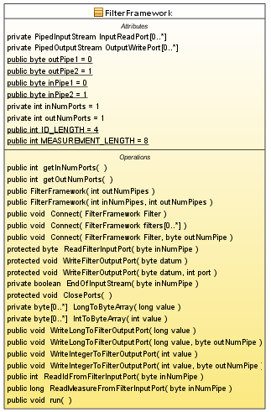

This new improved framework is used for creating all of the needed systems. Systems implementation was very fast and efficient process due to this agile framework. Now we are able to scale old and create new applications using this model in little to no time!

Static view of System A:
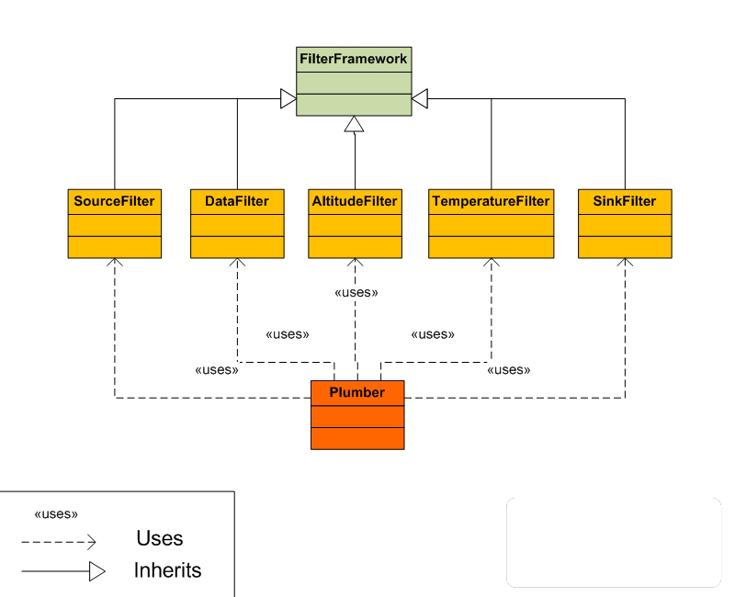

Static view of System B:
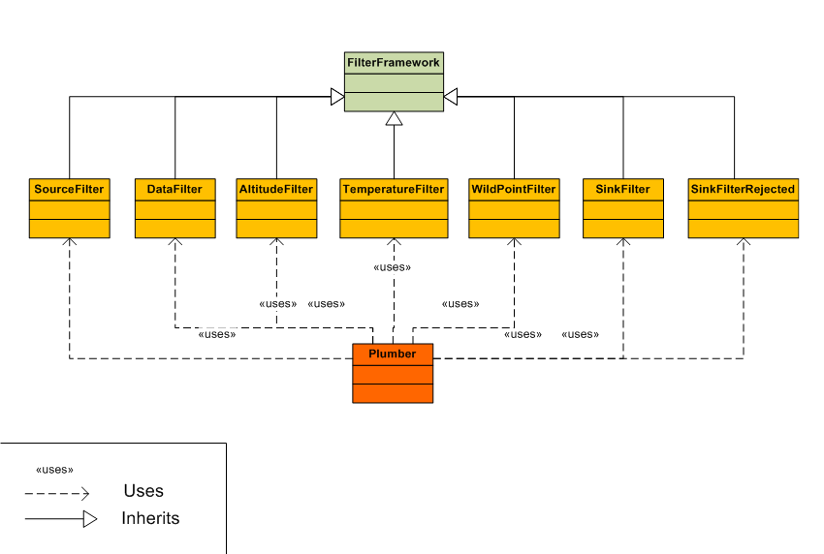

Static view of System C:
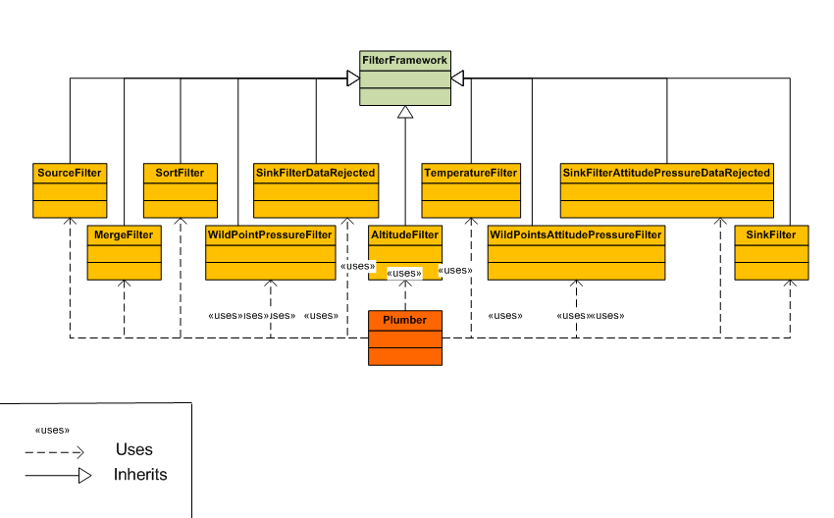

Bellow you can see dynamic view for systems A, B and C:
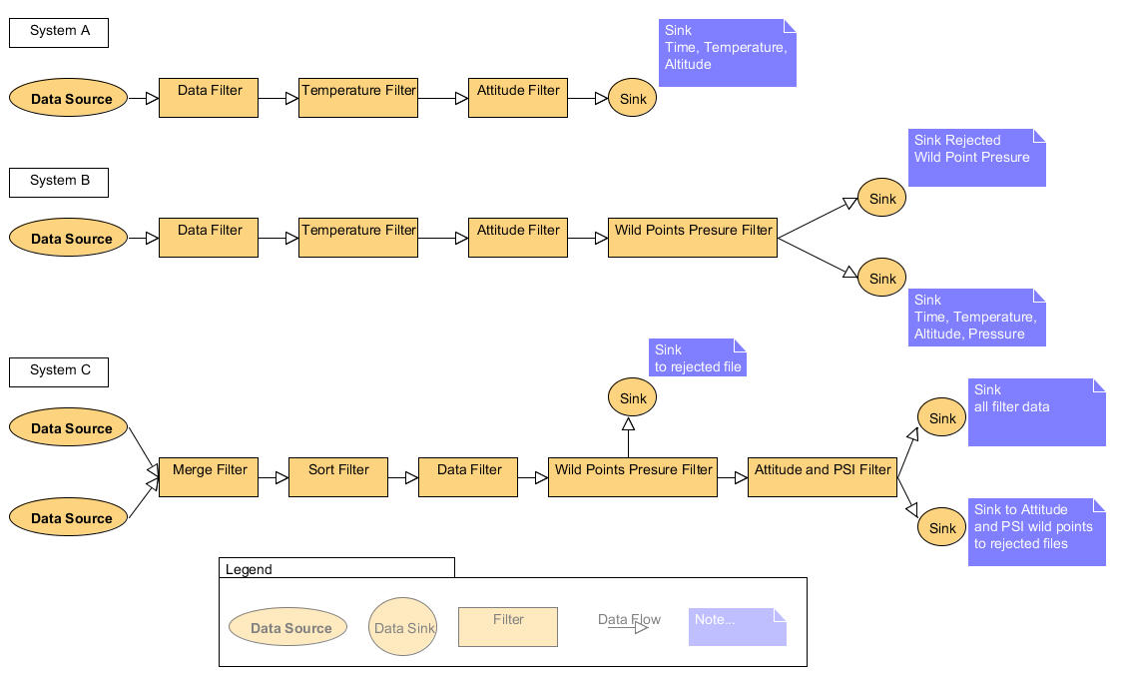

Every filter is careless what is happening at the previous and next steps in the chain. All what it does is reading data from its input, checks if incoming stream has to be filtered (in that case it makes programmed computations) or not and sends it to the next filter. Every filter can be swapped with any other and the system will continue to function, but some common sense has to apply, because even if we can swap any filter, we can't be sure that sinked data will be right due to the logic implemented in different filters.

- Discuss how well the design choices that you made support the business goals of the system in terms of the relevant quality attributes. What were the key design decisions, tradeoffs, and what motivated your choices?

Our design choices support very well business goals. As described before we went a couple of times through architectural design process implementing various different patterns and based on their evaluation we choose to use pipe and filter design pater, extending provided framework for using it. Which left us with:

- flexible, but not deviated from pipe and filter pattern framework;
- system which process byte streams of data from source to sink quick and efficient;
- very configurable software systems, which may be used for a variety of applications and processors;

- Are there any other possible solutions that you could have adopted? What made you decide on your solutions over these other possible solutions?

Yes as described above we have tried different approaches one of which for example was call-return design model. Pipe-and-filter fited best in meeting our architectural drivers. It provides modifiable filters. Filters are small and “simple” for support modules which are swappable.

3. Given your design and implementation of pipe-and-filter systems used for this assignment:

- To what extent do your implementations (A, B, and C) differ from what is implied by an idealized notion of pipes and filters? Explain why and the impact it might have on systemic properties of your systems.

In idealized notion of pipe and filters, each filter transmits data to the next and do not perform data processing or other operations that may affect the latency. Implementations of A, B, C adhere strictly to the initial framework. The framework is extended to support the business requirements (merge two stream, sort stream, sink). Also in system latency is introduced due to buffering in filters which is needed in order to process data. Biggest latency is introduced in wild points filters, because in order to interpolate wild points we have to buffer input till we get proper data.

- Is it possible for a developer to create circular dependencies in your systems? If so, what might be the result of executing a system with circular dependencies?

Yes it is possible, but this is not a good practice. This is considered as anti-pattern because of some negative effects:

- Reduce or make impossible the separate re-use of a single module.
- Can cause a domino effect, when a small local change in one modules spreads into other modules and has unwanted global effect.
- May also cause memory leaks.

4. Extension 1 (you are not required to implement this extension; however, describe the system in sufficient detail so that the architecture can be understood):

- Suppose that each filter needed information about each measurement. How might you pass along measurement metadata to each filter that included descriptions of the measurements such as measurement byte size, ID, units, and so forth? How might you satisfy this requirement? Sketch the architecture of this system, describe, and justify your design decisions and analysis.

We can implement it using our current framework. Of-course we will have to deviate a little from pipe-and-filter model due to introduced latency from parsing metadata. Metadata would be send as an coded data in 4 bytes, followed by another 12 bytes. We can associate different information for every value in first 4 bytes ID and next 12 bytes of data. This will work right away in our framework as long as we know the last ID number from the frame sequence bytes.

- How would this impact the key quality attributes of the system? How would the existing framework be affected? What mechanisms of the existing system might be affected by this requirement?

We don't think that it will introduce any major problems to our current framework nor affect quality attributes of the system more than filter do already.

- Would this system deviate from the idealized notion of a pipe-and-filter pattern? Explain why or why not and justify your answer.

We have already mentioned few times that we deviate from idealized notion of current architectural design, mainly because we introduce latency in stream which flows through out our pipes. This is inevitable, because we have to buffer for every filter different amount of bytes in order to process them.

5. Extension 2 (you are not required to implement this extension; however, describe the system in sufficient detail so that the architecture can be understood):

- Suppose there is a new requirement to run filters on separate processors as well as supporting co-located filter networks. How might you satisfy this requirement? Sketch the architecture of this system, describe, and justify your design decisions and analysis.

Current framework is already threaded, so running filters on separate processors depends a lot from underlying java virtual machine.

- How would this impact the key quality attributes of the system? How would the existing framework be affected? What mechanisms of the existing system might be affected by this requirement?

Our framework supports already running on multiple cores/processors systems. Execution time will improve and speed of concurrent processing data will increase impacting positively quality attributes drivers of the system.

- Would this system deviate from the idealized notion of a pipe-and-filter pattern? Explain why or why not.

We have already mentioned few times that we deviate from idealized notion of current architectural design, mainly because we introduce latency in stream which flows through out our pipes. This is inevitable, because we have to buffer for every filter different amount of bytes in order to process them.

